DEV-05: Dashboard and UI Prototyping

1. Overview
The prediction results are shown on a new Turnaround Prediction page inside the UPHSL Credential Tracker, opened from Predictions in the registrar's sidebar (/registrar/predictions). It is built with the same stack as the rest of the system: Laravel 12 with Livewire 4 components, Flux UI controls and Tailwind CSS 4 with the UPHSL brand colours. There is no separate dashboard program; the registrar uses one application for monitoring and prediction.
The page answers three questions for the registrar: how long will a request take, which requests already in progress are likely to be late, and how accurate have the predictions been.

2. Dashboard Requirements
Table 1. Required dashboard elements and where they are
Required element | Where it is on the page
System title | Page title "Turnaround Prediction" under the "UPHSL Registrar, Credential Tracker" sidebar header
Input section | "Try a request": credential type, copies, open requests and requester status
Submit / Predict | "Predict turnaround" button
Data / result display | Predicted ready date, due date and "How N days add up" breakdown
Prediction output | Predicted turnaround in days with an "At risk" or "On track" badge
Visualization / chart | Bar list of each input's contribution; scatter chart of predicted versus actual turnaround
Navigation / interaction | Sidebar navigation; links from the at-risk list to each request; live form

3. Screens
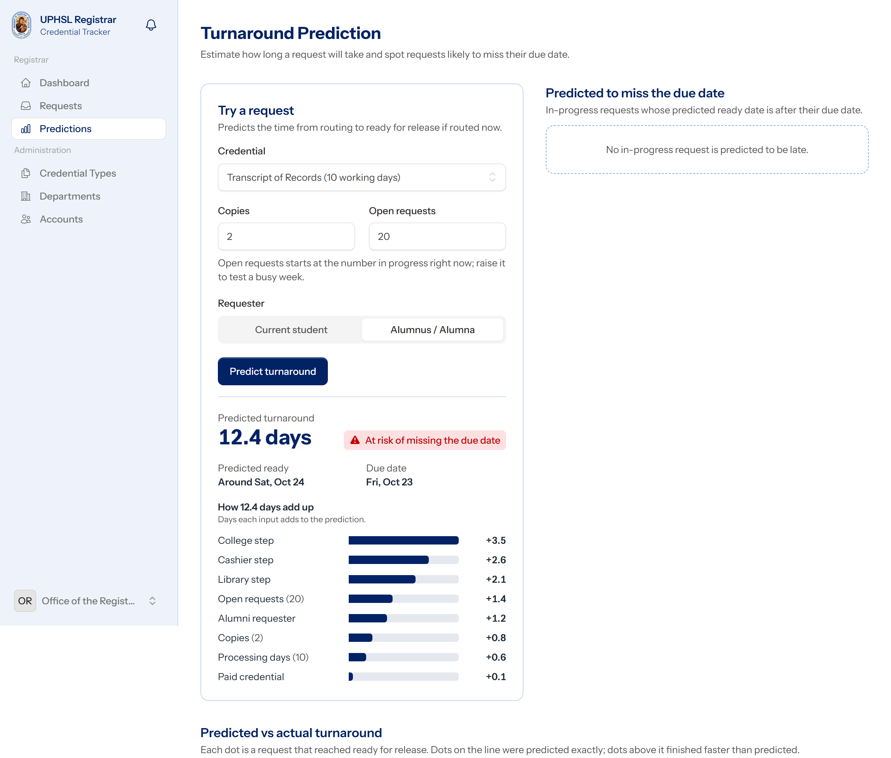
Figure 1. Predictions page after a prediction (staging demo data, desktop)
Figure 1 shows a Transcript of Records with 2 copies, an alumni requester and 20 open requests. The model predicts 12.4 days. Routed now (a Saturday night), the due date is Friday 23 October, so the predicted ready date of Saturday 24 October is late and the request is marked At risk of missing the due date. The bar list shows why: the college, Cashier and Library steps add the most days.
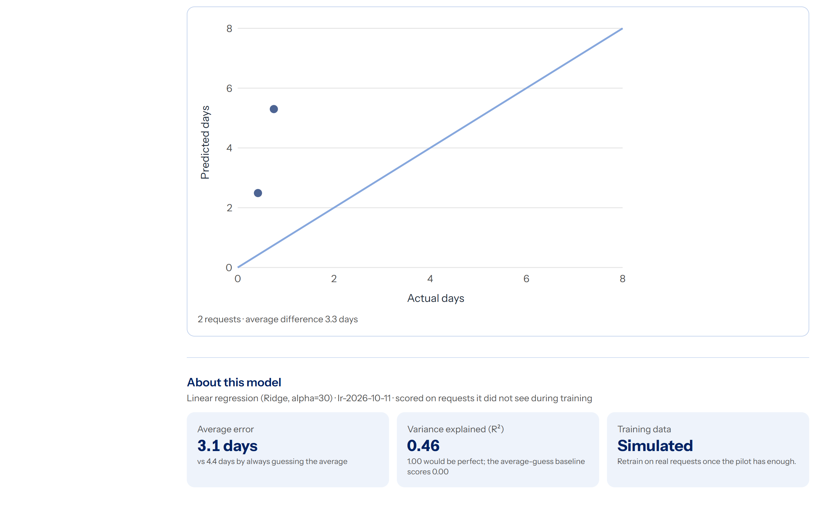
Figure 2. Predicted versus actual turnaround chart and model facts
The chart places every request that has reached ready for release by its actual days (across) and predicted days (up). Dots on the diagonal were predicted exactly. On the demo data both completed requests sit above the line: the demo seeder finishes them in under a day, faster than any real signing chain, so the model over-predicts them. With real pilot requests this chart becomes the running check required by Objective 5. Under it, "About this model" states the model's test error against the average-guess baseline and that it was trained on simulated data.
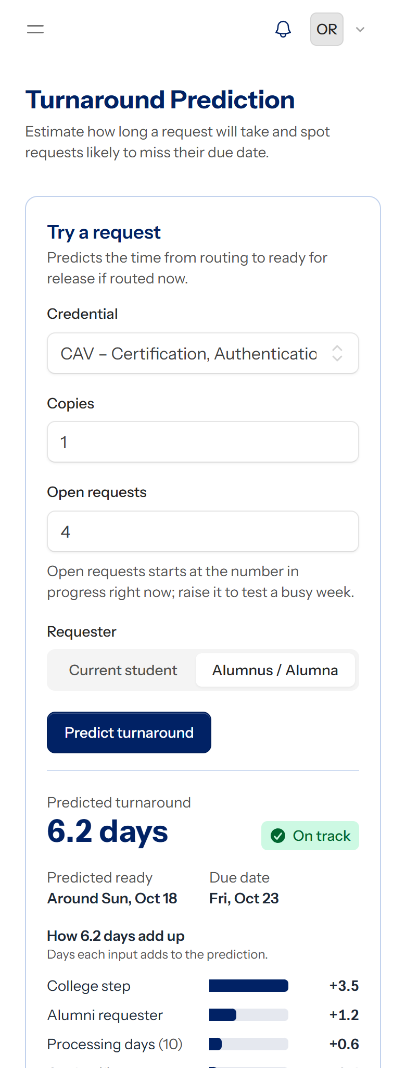
Figure 3. The same page on a phone (390 px wide)
On a phone the two columns stack, the form controls take the full width and nothing scrolls sideways, so the registrar can check a request away from the desk.
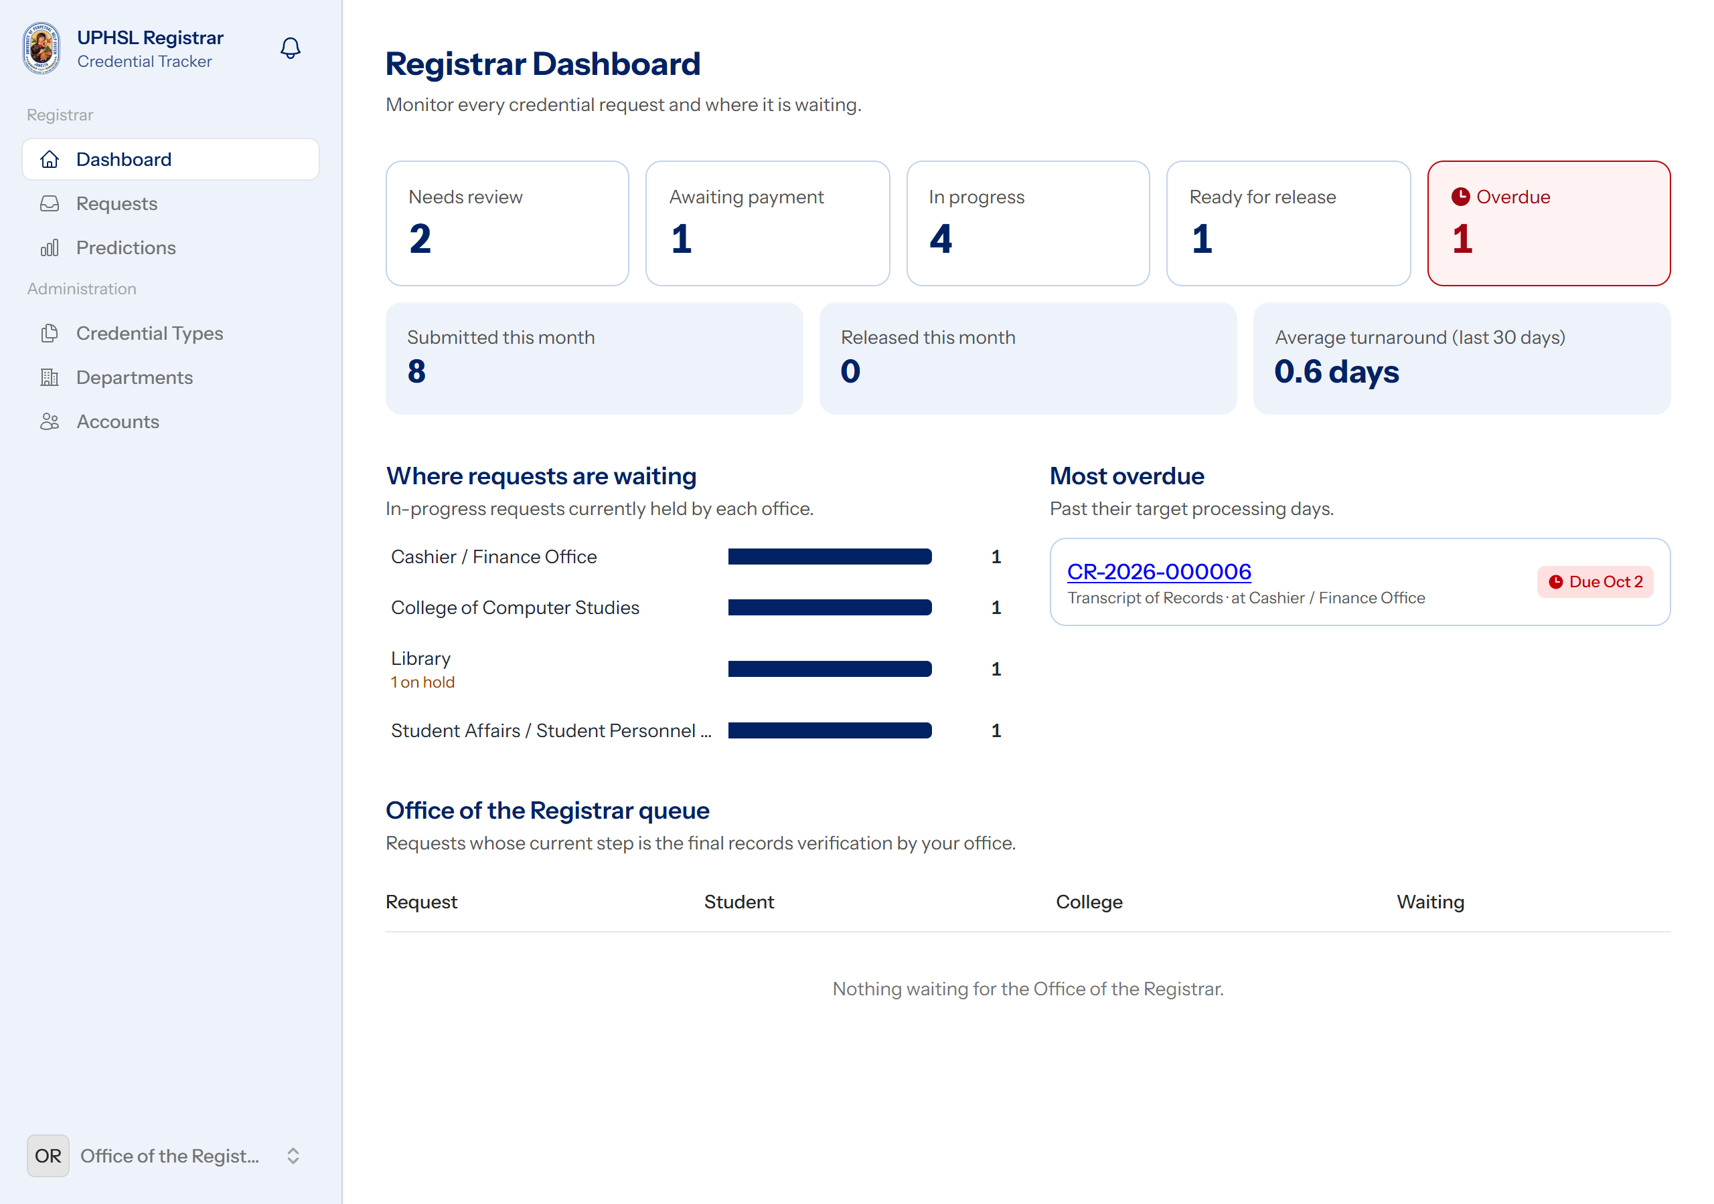
Figure 4. The existing registrar dashboard, with Predictions added to the sidebar

4. How to Use the Page
- Sign in as a registrar and choose Predictions in the sidebar.
- Choose the credential, the number of copies and whether the requester is a current student or an alumnus. "Open requests" starts at the number in progress right now; raise it to test a busy week.
- Click Predict turnaround. The result shows the predicted days, the predicted ready date, the due date, the at-risk badge and the breakdown.
- Check Predicted to miss the due date for real requests already in progress that the model expects to be late, and open any of them to follow up with the office holding it.

5. Interaction and States
Table 2. States the page handles
State | Behaviour
Loading | The Predict button shows a spinner and is disabled while the server computes
Invalid input | The browser blocks copies outside 1 to 10; the server checks every field again and shows the message under the field
Result | Predicted days, dates, badge (red "At risk" or green "On track") and breakdown
No requests at risk | "No in-progress request is predicted to be late."
No completed predictions yet | "No predicted request has reached ready for release yet." instead of an empty chart
Model file missing | An amber notice explains how to create it, and the Predict button is disabled; routing requests still works
Not a registrar | The page answers 403; the link is not in other roles' sidebars

Accessibility follows the rest of the system: every control has a visible label, the result is announced to screen readers (aria-live), the chart has a text description of what it shows, colour is never the only signal (the badges have text and icons), and everything works with the keyboard.

6. How the Page Gets Its Data
- The prediction uses the same TurnaroundPredictor service as the API (DEV-04), so the page and the API always give the same answer.
- The at-risk list reads the turnaround_predictions rows of requests that are still in progress and flagged at risk.
- The chart reads up to 200 requests that have both a stored prediction and a ready date, and compares the predicted days with the real routing-to-ready time.
- Model facts (error, R², training data) come from the model file written by ml/train.py.

7. Design Review and Testing
The page was reviewed with the Impeccable design checklist for task-focused app screens. The review moved the model details below the task, rounded the error to one decimal and placed it next to the baseline, removed false precision from dates (date only, "around"), and aligned the form inputs. It was then checked at desktop (1280 px) and phone (390 px) widths with no horizontal scrolling and no browser console errors.
Table 3. Automated tests for the page
Requirement | Test
REQ-08-09 | the registrar can try a request profile and see why (result, breakdown, validation error, 403 for a student)
REQ-08-10 | the page lists at-risk requests and compares predicted with actual

8. How to Run
composer install && npm install
APP_ENV=production php artisan migrate --seed # first time only
composer prod # builds assets, serves http://localhost:8001
For a demonstration with sample data, use staging instead: php artisan app:reset-demo, then composer dev, and sign in with the demo registrar account at http://localhost:8000.

